HW4.2 Centroids of Complex Shapes
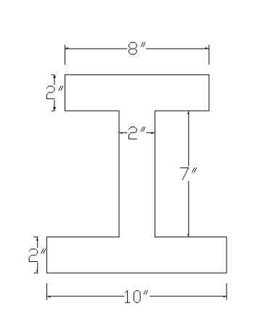
Find the centroid (x̄, ȳ) of the composite shape shown.

Given Dimensions
Bottom flange: 10 in × 2 in
Web: 2 in × 7 in
Top flange: 8 in × 2 in

Step 1: Break the Shape into Rectangles
1 = Bottom flange
2 = Web
3 = Top flange

Step 2: Table
Shape Area (A) Centroid y A·y
1
2
3
Total ΣA = _____________ Σ(A·y) = _____________

Step 3: Calculate y-bar
ȳ = Σ(Ay) / ΣA

ȳ = _____________ in

Step 4: Find x-bar
Is the shape symmetric? Yes / No
x̄ = __________ in

Final Answer
(x̄, ȳ) = (__________, __________)

Key Observation
The shape is symmetric about the vertical axis.
x̄ = center of width = 5 in (since total width = 10 in)
Step 1: Break into 3 Rectangles
1. Bottom flange
Width = 10, Height = 2
A₁ = 10 × 2 = 20
y₁ = 1
2. Web (middle)
Width = 2, Height = 7
A₂ = 2 × 7 = 14
y₂ = 2 + 7/2 = 5.5
3. Top flange
Width = 8, Height = 2
A₃ = 8 × 2 = 16
y₃ = 2 + 7 + 1 = 10
Step 2: Centroid Formula
ȳ = Σ(Ay) / ΣA
Step 3: Calculations
A₁y₁ = 20(1) = 20
A₂y₂ = 14(5.5) = 77
A₃y₃ = 16(10) = 160
Σ(Ay) = 20 + 77 + 160 = 257
ΣA = 20 + 14 + 16 = 50
Final Answer
ȳ = 257 / 50 = 5.14 in
(x̄, ȳ) = (5.00, 5.14) in

